Islamic Center of Greater Cincinnati plans for Muslim holy month during pandemic
Ramadan one of many holidays disrupted this April
The holy month of Ramadan is traditionally a time of togetherness at the Islamic Center of Greater Cincinnati, but this year will have to be different.
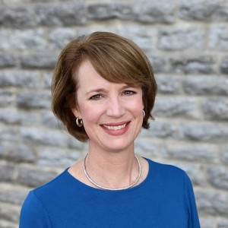
By: Lucy May
Posted at 5:00 AM, Apr 22, 2020

and last updated 5:03 PM, Apr 22, 2020
WEST CHESTER, Ohio — The holy month of Ramadan is traditionally a time of togetherness at the Islamic Center of Greater Cincinnati in West Chester.
As many as 1,000 people attend nightly prayers at the mosque during the week, and the number of faithful can top 1,500 on the weekends, said Dr. Amir Izhar, the chairman of the Islamic Center’s board.
“We all look forward to this month of Ramadan,” he said. “It’s all about being together, praying together and being socially together.”
But because of the COVID-19 crisis, things will be much different this year when Ramadan starts at sundown Thursday. In the same way so many other places of worship have had to change how they celebrated holidays this spring, the Islamic Center has had to make dramatic changes to the way it marks the holiest month of the year for Muslims.
“It’s going to be completely different,” said Dr. Samina Sohail, who serves as secretary of the Islamic Center’s board. “Since I was a child, Ramadan has been filled with memories of going to the mosque every night, whether it was in Florida where I grew up or in the years I have lived here. So not having that is going to be a big void.”
The center has been livestreaming daily and Friday prayers since mid-March because of the pandemic. It will continue that approach with the extended nighttime prayers that are such an important part of Ramadan, Izhar said.
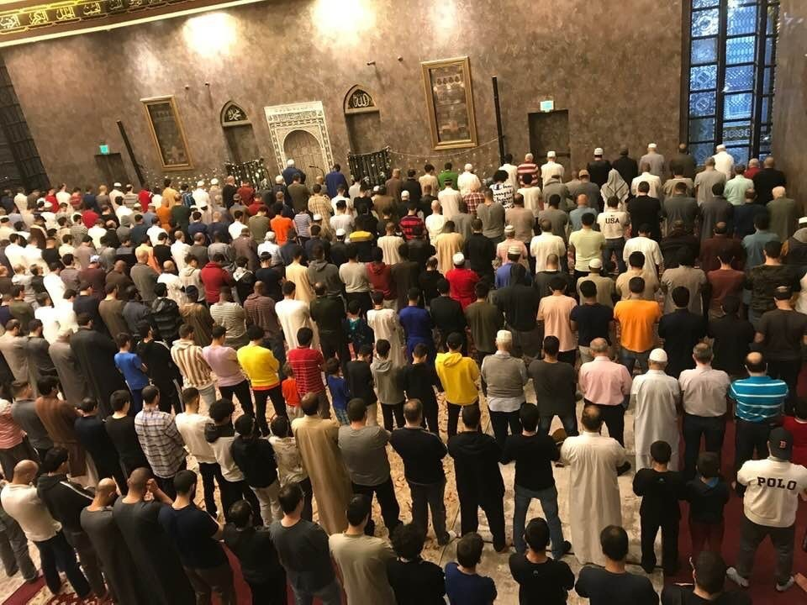
Courtesy of Samina Sohail
This photo shows men praying in the mosque on one of the nights of Ramadan.
“It’s starting to sink in that this is going to be a new norm, at least for now, and we’re just going to have to be careful and continue to be careful even if it starts to relax,” he said. “We need to make sure that we’re 110% safe before we start congregating and congregating in a big way.”
Those changes have been difficult for people across many faiths. Ramadan is among a number of holidays this month representing six faith traditions: Easter; Passover; Ramadan; Ridvan, a 12-day festival in the Baháʼí Faith; Vaisakh, a new year’s celebration in both the Sikh and the Hindu faiths; and Maidyozarem Gahambar, the Zoroastrian mid-spring festival.
The local interfaith group EquaSion launched a series of webinars called “Turning to Faith” to help the many Cincinnati faithful who have had to adjust the way they worship.
“The goal is to provide some answers to folks who are seeking guidance on how can I find hope, how can I find courage, how can I find a sense of community when I’m confined in my home,” said Chip Harrod, EquaSion’s executive director. “It’s a time when religious diversity really needs to be celebrated.”
‘We’re all in this together’
The series also offers people of faith another way to uplift themselves and each other spiritually, said Shakila Ahmad, the Islamic Center’s emeritus board chair.
“You can be spiritually uplifted by seeing other people in their actions of faith,” she said. “I’ve had people come for a tour of the Islamic Center, observe prayer and say, 'I’ve never felt closer to God than I did right now.'”
Ahmad said she has always felt that way during Ramadan as part of a congregation listening to the imam’s recitation of the Quran. When she was chair of the Islamic Center’s board, she said she spent nearly every night of Ramadan at the center, worshipping and then breaking the daily fast with friends and family members.
But this year’s new remote approach does provide opportunities.
“It’ll be both an opportunity and a challenge to really leverage that energy that we want to expend to do that spiritual uplifting of self, spiritual uplifting of others and service to others in different ways,” Ahmad said.
The core principal of Islam, after all, is taking care of other people, Izhar said.
“I think we just have to remind us what any faith and religion teaches us, especially Islam, and practice the best that we can so we can get over this hump, this pandemic, which at this point is still trying to affect humanity,” he said. “But we’re trying to do the best we can to fight it out.”
Sohail said she knows her four children are disappointed that they won’t get to celebrate Ramadan with their friends at the Islamic Center like they have in years past.
But she said she hopes they look back on this time with some fondness when they’re adults.
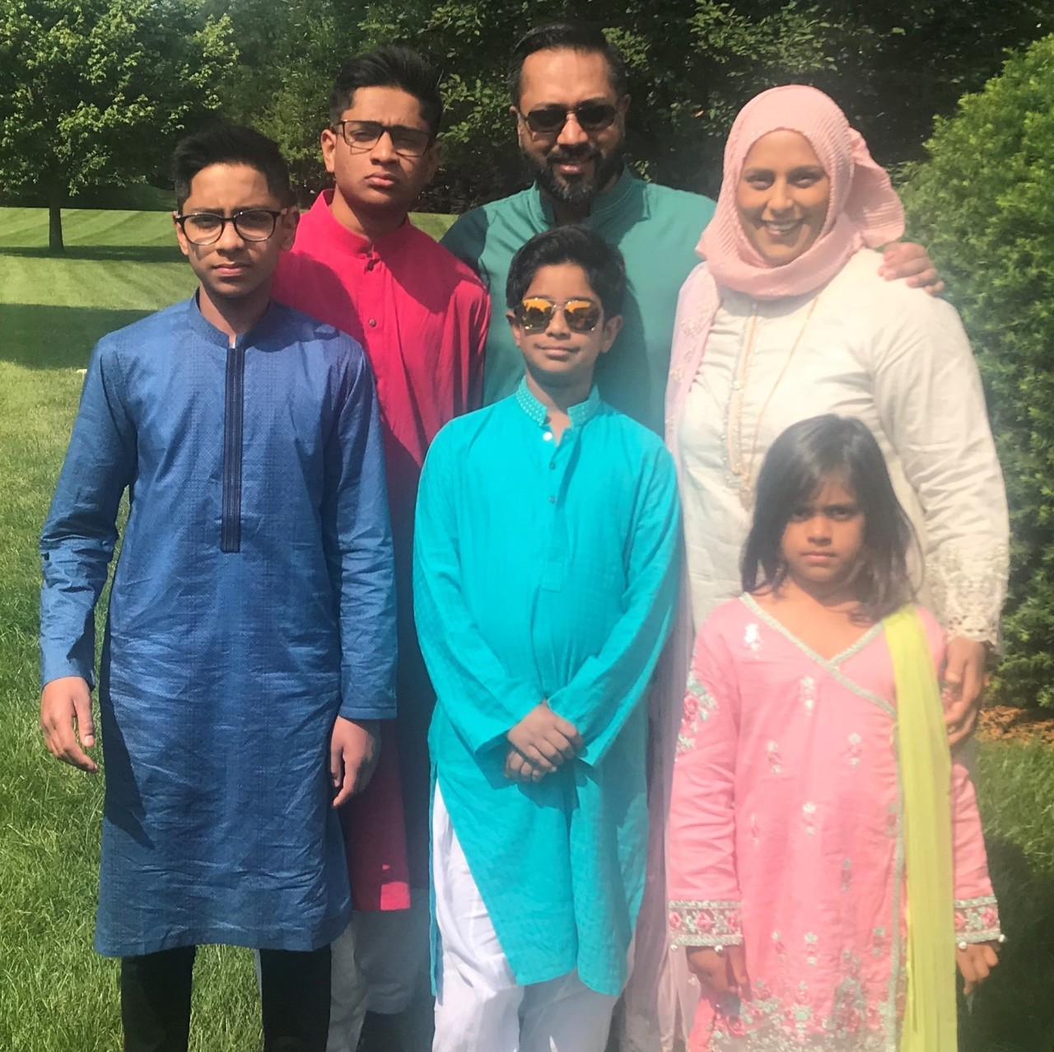
Courtesy of Samina Sohail
Dr. Samina Sohail, in the back row, far right, with her family on Eid Day.
“I hope they look back at it as a time when they got to spend more time with their parents,” she said. “We did the best we could, we ate a lot of good food, we watched a lot of good movies, we took a lot of good walks. At the end of the day, you won’t get this time back.”
It’s one of those silver linings of the pandemic that so many parents across Greater Cincinnati are trying to appreciate.
Harrod said he hopes the pandemic and his organization’s “Turning to Faith” series will help people across the Tri-State find more in common with each other.
“I think now folks are more open, frankly, to learning about other people and accepting them,” Harrod said. “Because at the end of the day, we’re all dealing with this pandemic, regardless of our faith, of our race, of our ethnicity, of our orientation. We’re all in this together. So as long as we’re all in this boat together we need to find out about one another.”
The Islamic Center's YouTube channel has videos of live-streamed prayers and recitations. More information about the Islamic Center of Greater Cincinnati is available online.
Registration for any of the remaining three webinars in the “Turning to Faith” series is available online, too.
Lucy May writes about the people, places and issues that define our region – to celebrate what makes the Tri-State great and shine a spotlight on issues we need to address. To reach Lucy, email lucy.may@wcpo.com. Follow her on Twitter @LucyMayCincy.
Copyright 2020 Scripps Media, Inc. All rights reserved. This material may not be published, broadcast, rewritten, or redistributed.

