COVID-19 And End-Time Prophecy
Published:Sunday | May 31, 2020 | 12:25 AMCecelia Campbell-Livingston - Sunday Gleaner Writer
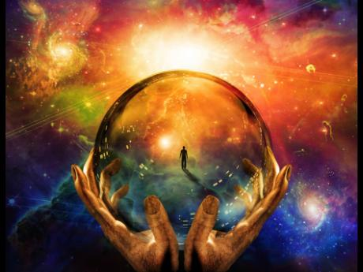
“In that greatness of morning
Fair thee well, fair thee well.
In that greatness of morning
Fair thee well, fair thee well.”
– Ride On King Jesus, Traditional Negro Spiritual
The COVID-19 pandemic which is sweeping the world and causing thousands of deaths, has many persons, including Christians, thinking that the world is coming to an end.
Some Bible scholars are even finding scriptural references to validate their claim that we are now approaching the ‘beginning of the end’. To hear them expound, one would expect, any day now, to see the clouds burst open and Christ making His long-prophesied, glorious return.
But is this just another pandemic, like the Spanish Flu in 1918, which swept the world and killed an estimated 50 million persons - far more than COVID-19 has done so far; or is it a sign that Christians should indeed be looking up as their ‘redemption is drawing nigh’?
Family and Religion asked Rev Dr Zebulah Aiken for her perspective on the matter, and she responded by saying that no one, not even God’s son, Jesus, knows the minute or the hour when God will be putting in his appearance.
Christians, Aiken said, should always live their lives in a state of readiness so that, whether it is COVID, an accident, illness or the actual return of Jesus, they will be ready to meet Him.
“Throughout the years, many have been using events to mark end times. If you recall when we were just entering 2000, many were nervous as they thought it would be the end. Think about the many false prophets who deceived and caused their followers to die,” she shared, adding that one should search the scriptures and not be swayed by everything that is going on around them.
Getting into scriptures, Aiken said there is no secret surrounding Christ’s second coming. The book of Revelation, she said, expounds on a series of events that MUST occur before, and with Christ Himself stating that the gospel must reach the “end of the world” before He puts in His appearance.
According to Aiken, COVID is serious and it has taken many lives, and has left several persons fearful and thinking about their souls, with some even questioning God’s goodness and His ability to intercede.
All that, the reverend said, is good and it is opening up the conversation for die-hard unbelievers.
But is it the end?
“No, I don’t think it is, but I will say it is time for all – both Christians and the unsaved - to take a retrospective look at their own lives and make things right before God,” she said.
Aiken added that catastrophes are nothing new to mankind. In fact, she used the Bible to make reference to a time when the prophet Jeremiah had to deal with one such cataclysm.
Over the centuries, there has been one calamity after another, and Aiken said that persons from those eras, while experiencing the disaster, thought, as now, that they were in the end times.
However, Aiken stressed that, instead of being so fixated about end times and making predictions, persons should instead turn their attention to being each other’s keepers, assisting those who are in need, and stop stressing about things they have no real understanding or control of.

