GG declares 2 days of prayer and fasting
Friday, March 20, 2020

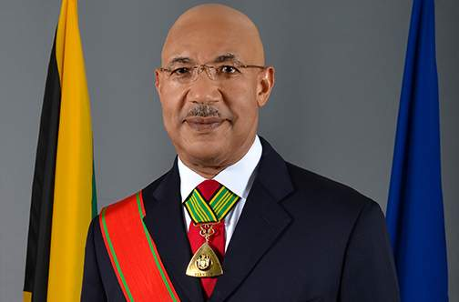
Governor General Sir Patrick Allen
ST JAMES, Jamaica— Governor General Sir Patrick Allen has declared two days of prayer and fasting, beginning today, in response to the outbreak of the novel coronavirus (COVID-19).
The declaration was read a short while ago by Custos of St James, Bishop Conrad Pitkin, at a press conference held at the Faith Temple Assembly Church in Montego Bay.
The two days of prayer and fasting, which has been organised by the Jamaica Umbrella Group of Churches (JUGC), will commence at 6:00 pm and runs until 6:00 pm on Sunday, March 22.
Allen in his proclamation appealed to all people of faith across the island and the diaspora to observe any of, or all of the two days for prayer and fasting.
For his part, Custos Pitkin in reminding Jamaicans to practise proper hygiene, appealed to all to be calm.
He also commended the government for its handling of the pandemic.
Up to yesterday the country recorded 16 confirmed cases and one death due to COVID-19.

