Top Jewish Leader Praises President Trump for Commitment to Fighting Antisemitism Amid COVID-19 Crisis

by Benjamin Kerstein
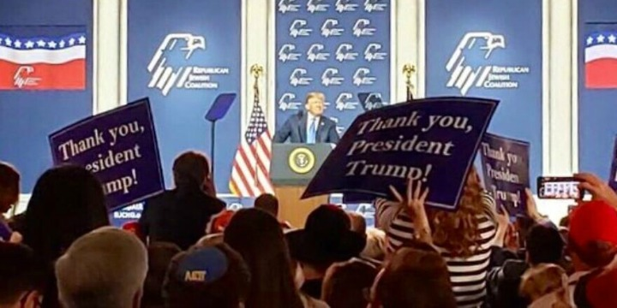
US President Donald Trump speaks to the audience at the Republican Jewish Coalition in Las Vegas on April 6, 2019. Photo: Wikimedia Commons.
May 3, 2020
The head of a leading international Jewish group praised US President Donald Trump over the weekend for a proclamation condemning antisemitism, saying, “I know personally that he is committed to eradicating the spread of antisemitism from our society.”
“President Trump has consistently stood by American Jewry and the State of Israel throughout his tenure,” said World Jewish Congress President Ronald Lauder. He added that Trump’s commitment applies “even in the midst of the present immense global uncertainty and concerns accompanying the COVID-19 crisis.”
GET THE BEST OF THE ALGEMEINER STRAIGHT TO YOUR INBOX!
SIGN UP!
“As the president emphasized … antisemitic discrimination, persecution, and violence continue to plague our Jewish communities,” Lauder noted, saying the president’s words “must be repeated, over and over again … until it is made absolutely clear that incitement, bigotry, hatred, and xenophobia will not be tolerated.”
“The World Jewish Congress deeply appreciates the US administration’s ongoing efforts to combat the evil of anti-Jewish hatred, and its continuing support of American Jewry in its cherished traditions and innumerable contributions to society,” he added. “We look forward to the day when we will be able to say that antisemitism has truly been eradicated in America.”
Lauder’s comments came in response to a proclamation late last week marking Jewish American Heritage Month. In the statement Trump said, “Hatred is intolerable and has no place in our hearts or in our society. We must therefore vigorously confront antisemitic discrimination and violence against members of the Jewish community.”
“This month, we reaffirm our commitment to never compromise our steadfast support for the Jewish community, our rejection of antisemitic bigotry, and our disdain for malicious attacks of hatred,” the president added.

