Pastors islandwide join in prayer for COVID-19
Friday, April 10, 2020 4 Comments

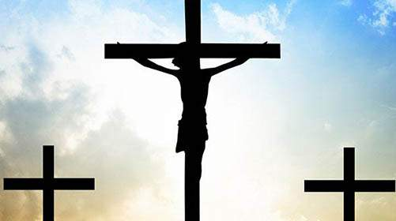

KINGSTON, Jamaica – Over 1,000 pastors and church leaders are expected to participate in a three-hour virtual prayer meeting to petition what they say is "the throne of grace" on behalf of Jamaica for COVID-19. The meeting which is being staged under the theme “Standing in the Gap” is spearheaded by the Jamaica Umbrella Groups of Churches (JUGC). It will take place on Tuesday April 14, 2020 starting at 9:00 am.
Chairman of the organising committee, Rev Adinair Jones believes the coming together of this large group of ministers from the various church groups in Jamaica is necessary because of the health and economic impact that COVID-19 has had so far on Jamaica and the world.
“I believe this is a significant and urgent time in earth's history to call pastors and church leaders to come together for a time of reflection and prayer as we seek God's intervention in stopping the spread of COVID-19 and to find solutions.
“It is also to prayerfully prepare the church community and the nation to undertake the humanitarian tasks in relation to the impact the ravaging virus has had on the human community, including loss of lives, cases of infection and fall out of financial and social support,” said Rev Jones.
Reverend Jones is also calling on all pastors to use this period to unite around a time of personal reflection, thanksgiving, lamentation, supplication and repentance.
“Prior to the outbreak of COVID-19, plans were well advanced for a national gathering of all pastors to reflect and pray, but that format had to be postponed in keeping with directives handed down by the government to stop the spread of the virus,” he explained
“At this time of uncertainty, tragedy and fear, it is our responsibility as leaders of our respective churches to maintain not only safety measures for our members and the wider society, but to strengthen our faith in this time of crisis,” Rev Jones continued.
The JUGC comprises seven groups of churches: Jamaica Council of Churches; Jamaica Association of Full Gospel Churches; Jamaica Evangelical Alliance; Jamaica Pentecostal Union (Apostolic); Church of God in Jamaica, Independent Churches of Jamaica and the Jamaica Union Conference of Seventh-day Adventists. It represents 96 per cent of the island's Christian community.

